03-JUL-2007: PatientPix by OcucoRelcon
The optician’s conundrum: patients want to see themselves wearing their new frames, but they cannot see clearly their image in the mirror.
There are many hi-tech solutions to solve this problem, but their affordability and the all-important ROI (Return On Investment) require deeper analysis – what if there was a solution so affordable and so simple that you could embrace it without having to convince your accountant.

Enter PatientPix by OcucoRelcon.

PatientPix is a simple, low cost solution designed to satisfy the need within an optical practice for visual dispensing. It allows you to take digital photos of your customers wearing a variety of different spectacle frames and present the photos in a format that allows the patient to compare the results on screen.

PatientPix can be configured to display either 9 or 4 photos per page.

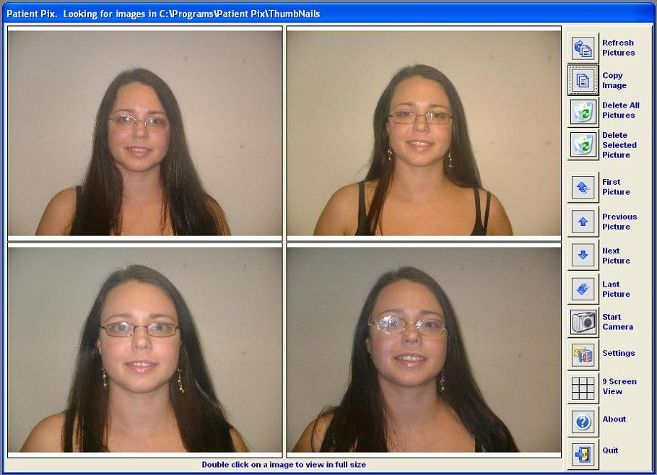

The key to the success of PatientPix is in its simplicity: simple to purchase, easy to install and intuitive to use, requiring no additional training.

The software is designed to auto-install and is stand-alone i.e. it will work independent of practice management software, not just the highly acclaimed OcucoRelcon PMS systems Acuitas and Focus.

And how do you go about obtaining it? Again simple, PatientPix is available for download from the OcucoRelcon and Ocuco websites as a single, self-installing file (see technical requirements below).

PatientPix is sold on a “per seat” basis. Once downloaded and installed, a simple phone call to the local OcucoRelcon office, and a valid credit card is all that’s needed to receive a unique activation code. Couldn’t be simpler.

PatientPix will work with any Windows compatible webcam, but it must be capable of taking images at least 800x600 pixels at 30fps (frames per second). This is also known as a VGA webcam. Picture size and quality are entirely dependant on the Webcam used, and there are lots of models today to choose from at varying prices.

http://www.ocucorelcon.com/

